Write a Blog on the below topic (1500 -2000 word count) Virtual Private Cloud (VPC)

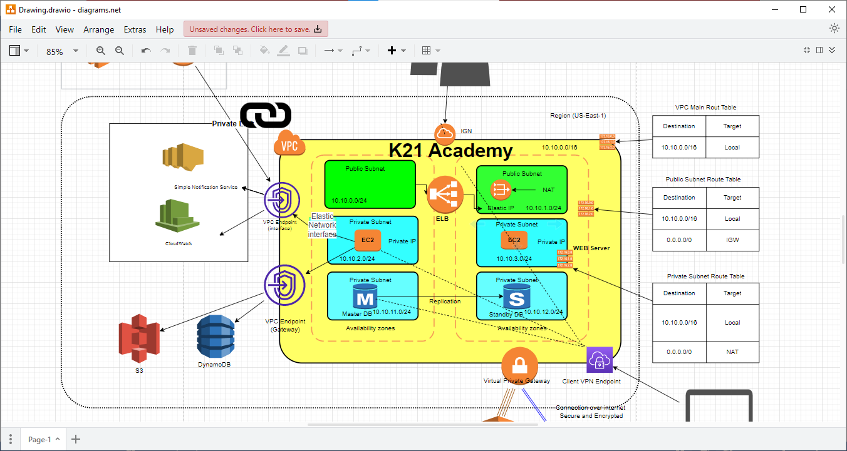

VPC or Virtual Private Cloud is a service provided by Amazon Web Services (AWS) that enables users to create and manage their own virtual network environments within the AWS cloud. It offers a highly scalable and customizable network infrastructure, allowing organizations to build secure and isolated virtual networks for their AWS resources All the Critical Resources are located inside the VPC it acts as a boundary for the traffic to flow in and flow out.

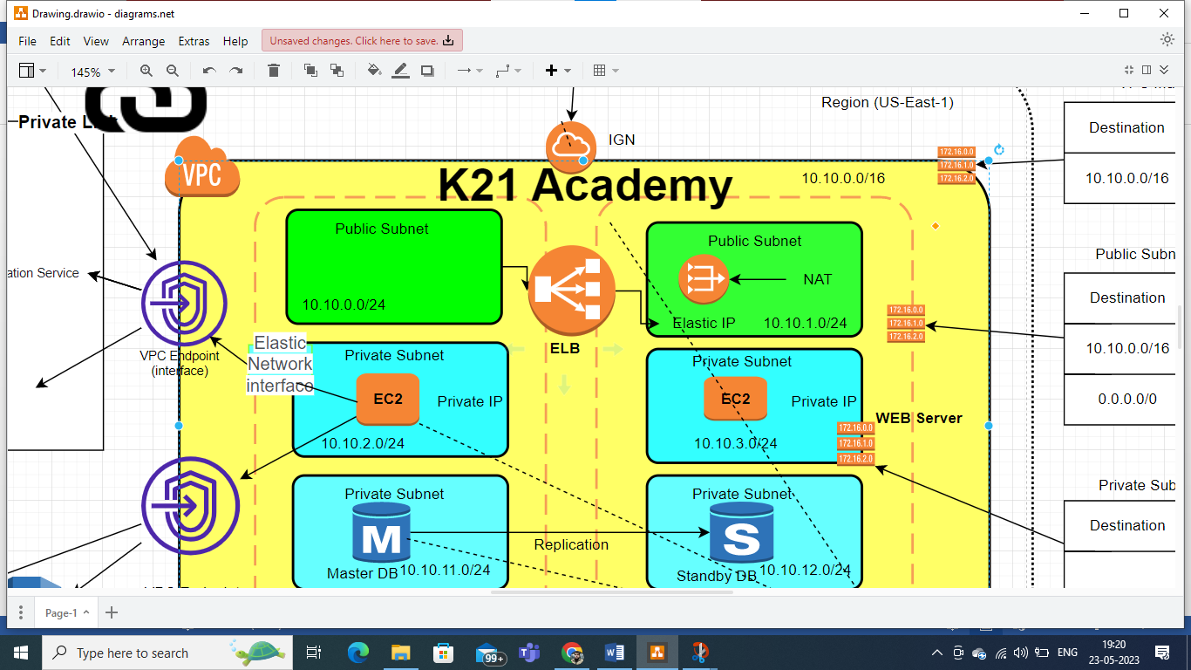

There are three Subnets in each region. Two Private and One Private Subnets in a Virtual Private Cloud (VPC) are subdivisions of the VPC's IP address range. They enable the logical segmentation of resources within the network. Each subnet has its own IP address range and can be associated with specific availability zones. Subnets allow for network segmentation, routing control, and security enforcement. They can be configured as public or private, depending on internet connectivity requirements. By using subnets, organizations can effectively organize and manage their resources, control network traffic, and enhance security within their VPC. Routing tables are an essential component of a network infrastructure, including within a Virtual Private Cloud (VPC) in AWS. They provide the necessary instructions for directing network traffic between different subnets, internet gateways, virtual private gateways, and other network resources within the VPC in AWS VPC, each subnet is associated with a specific routing table that controls the flow of traffic within that subnet.

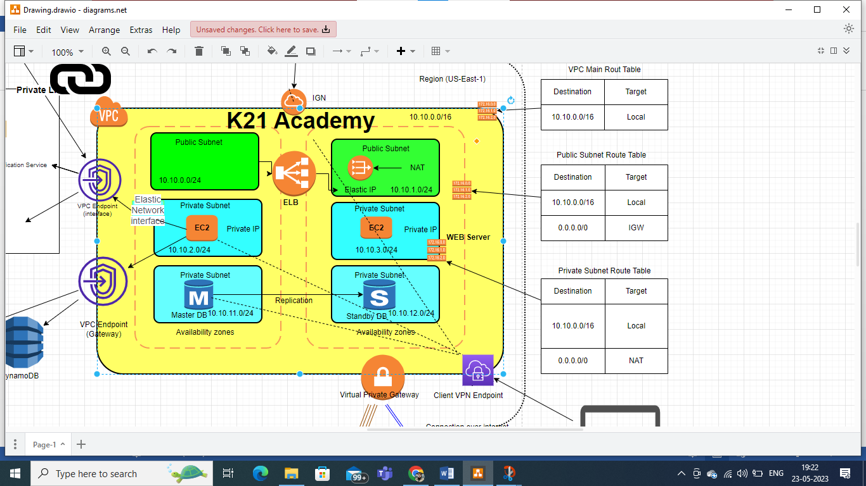

The Route table for the Private subnet routs packets to the NAT gateway. The NAT with ELB and IGW has direct connectivity to internet. Routing tables consist of entries, also known as routes, which define how network packets are forwarded. These routes specify the destination CIDR (Classless Inter-Domain Routing) blocks and the target for the traffic. When a network packet arrives at a subnet, the routing table is consulted to determine the appropriate next hop for the packet. The routing table uses the longest matching prefix rule, which means it looks for the most specific route that matches the destination IP address of the packet. Routing tables are an essential component of a network infrastructure, including within a Virtual Private Cloud (VPC) in AWS. They provide the necessary instructions for directing network traffic between different subnets, internet gateways, virtual private gateways, and other network resources within the VPC. In AWS VPC, each subnet is associated with a specific routing table that controls the flow of traffic within that subnet. Routing tables consist of entries, also known as routes, which define how network packets are forwarded. These routes specify the destination CIDR (Classless Inter-Domain Routing) blocks and the target for the traffic. When a network packet arrives at a subnet, the routing table is consulted to determine the appropriate next hop for the packet. The routing table uses the longest matching prefix rule, which means it looks for the most specific route that matches the destination IP address of the packet.

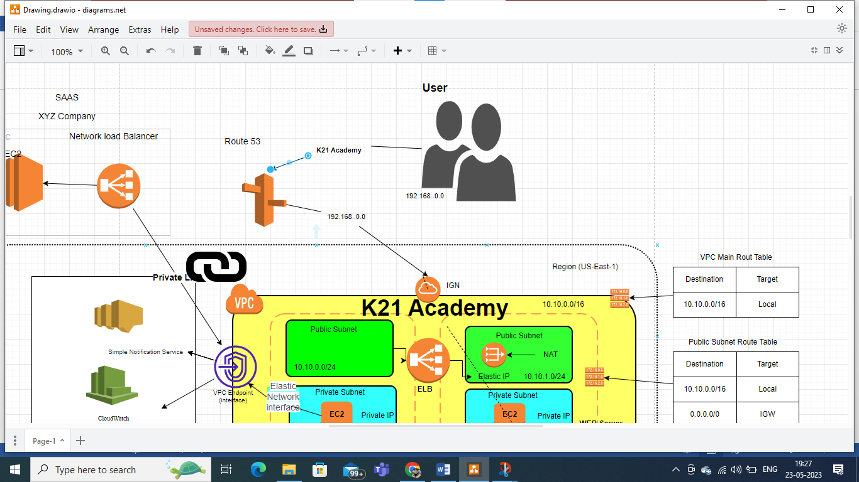

An internet gateway is a vital component of an AWS Virtual Private Cloud (VPC) that provides a secure and reliable connection between instances within the VPC and the internet. It acts as a gateway for inbound and outbound internet traffic, enabling resources within the VPC to communicate with external networks and services. When deploying resources in a VPC, an internet gateway is associated with public subnets. Public subnets have routes that direct traffic to the internet gateway, allowing instances within those subnets to access the internet. This is essential for various use cases, such as web servers or instances requiring access to external APIs or services. Outbound traffic from instances within the VPC is routed through the internet gateway. This enables instances to access external resources, download updates, or interact with other cloud services. Inbound traffic from the internet is also facilitated by the internet gateway, allowing external requests to reach instances within the VPC. However, security measures, such as configuring security groups and network ACLs, should be implemented to control and filter inbound traffic.

NAT Gateways: A NAT (Network Address Translation) gateway is a managed service provided by AWS that enables resources within a private subnet of a Virtual Private Cloud (VPC) to access the internet while remaining protected from direct inbound internet traffic. Outbound Internet Connectivity: NAT gateways allow instances within private subnets to communicate with the internet. They act as a gateway for outbound traffic, enabling resources to access external services, software updates, and other internet-based resources. IP Address Translation: When instances in a private subnet send requests to the internet, the NAT gateway translates their private IP addresses to its own public IP address. This hides the private IP addresses from the internet and provides an extra layer of security. Stateless Architecture: NAT gateways operate in a stateless manner, meaning they don't maintain information about the state of connections. This allows them to handle a large volume of traffic efficiently. High Availability and Scalability: AWS automatically provisions NAT gateways in multiple Availability Zones to ensure high availability and redundancy. This architecture provides fault tolerance and ensures that instances in private subnets can maintain internet connectivity even if one availability zone experiences issues. Integration with Route Tables: NAT gateways are associated with the route tables of private subnets. This association allows outbound traffic from instances in the private subnet to be directed to the NAT gateway. Billing: NAT gateways have an hourly usage-based pricing model, which includes data processing and data transfer charges.

Security groups in AWS are virtual firewalls that control inbound and outbound traffic for EC2 instances. They act as a first line of defence, allowing administrators to define rules that permit or deny specific types of traffic. Security groups operate at the instance level, meaning each instance can be associated with one or more security groups. They are stateful, which means that if an inbound rule allows traffic, the corresponding outbound rule automatically allows the response traffic. Security groups provide a flexible and robust way to enforce network security policies and protect resources within an AWS environment.

Network Access Control Lists (ACLs) in AWS are an additional layer of security that operates at the subnet level to control inbound and outbound traffic. They act as a firewall for controlling traffic flow in and out of the subnets within a Virtual Private Cloud (VPC). Here are key points about Network ACLs:

1. Subnet-Level Control: ACLs are associated with subnets and evaluate traffic at the subnet boundary. They provide a set of rules that allow or deny traffic based on source and destination IP addresses, ports, and protocols.

2. Order of Evaluation: ACL rules are evaluated in a sequential order. Unlike security groups, which operate on a "deny by default" principle, ACLs have an "allow by default" behaviour. This means that if no explicit rule matches, the default rule allows the traffic.

3. Stateless: ACLs are stateless, which means that they do not keep track of the state of connections. Each network packet is evaluated independently based on the rules in the ACL.

4. More Granular Control: ACLs offer more granular control over traffic flow compared to security groups. Each ACL rule can permit or deny specific traffic, allowing for fine-grained access control.

5. Inbound and Outbound Rules: ACLs have separate inbound and outbound rules. Inbound rules control incoming traffic to the subnet, while outbound rules control outgoing traffic from the subnet.

6. Rule Numbering: ACL rules are assigned a unique rule number that determines their order of evaluation. Lower-numbered rules are evaluated before higher-numbered rules. Network ACLs provide an additional layer of control and security for subnets within a VPC. They allow administrators to define specific rules for traffic flow, enhancing network security and protecting resources within the VPC.

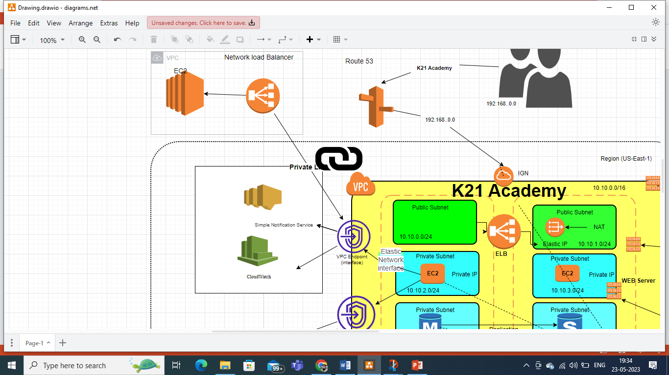VPC peering is a networking feature provided by AWS that enables connectivity between two Virtual Private Clouds (VPCs) in the same AWS region. It allows the VPCs to communicate with each other as if they were on the same private network. VPC peering simplifies network architecture by eliminating the need for complex and costly solutions such as VPN connections or hardware-based networking. When two VPCs are peered, they can exchange traffic using private IP addresses. This means that resources within each VPC can communicate directly, securely, and efficiently without the need for internet access or traversing public networks. The communication between peered VPCs is highly reliable, low-latency, and does not incur any data transfer costs. Key features of VPC peering include:

1. Inter-VPC Communication: Peered VPCs can exchange traffic between instances, services, and resources using private IP addresses. This enables seamless connectivity and sharing of data and services between VPCs.

2. Security and Isolation: VPC peering operates within the AWS backbone network and does not require any gateways or public endpoints. This ensures that the communication remains private, secure, and isolated from the internet and other VPCs.

3. Scalability and Simplicity: VPC peering supports a scalable and simplified network architecture. It allows organizations to easily connect and manage multiple VPCs without the need for complex configurations or additional networking components.

4. Cross-Account Peering: VPC peering can be established between VPCs in different AWS accounts, providing a secure and controlled method for communication between different organizations or departments.

5. Transitive Peering: VPC peering supports transitive peering, which means that if VPC A is peered with VPC B and VPC B is peered with VPC C, then VPC A can communicate with VPC C through the transitive relationship. 6. Routing and CIDR Overlapping: VPC peering handles routing transparently and automatically. It supports overlapping CIDR blocks in the peered VPCs, allowing organizations to retain their existing IP addressing schemes. VPC peering is a powerful feature that enhances network connectivity and simplifies the communication between VPCs in the same AWS region. It provides a secure, scalable, and cost-effective solution for building complex multi-tiered architectures, implementing distributed applications, or enabling collaboration between different AWS accounts or organizations.

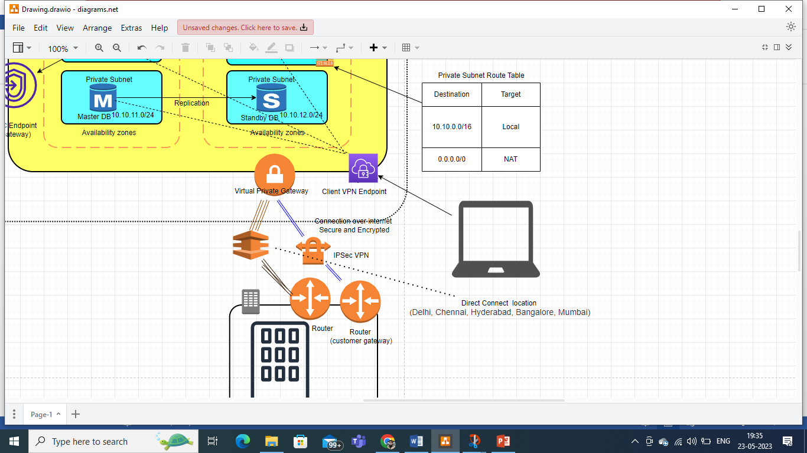

A Virtual Private Network (VPN) is a technology that establishes a secure and encrypted connection over a public network, typically the internet. It allows users to securely access and transmit data between remote locations or devices as if they were connected directly to a private network. Here are key points about VPN:

1. Secure Data Transmission: VPNs create a secure tunnel between the user's device and the destination network, encrypting the data transmitted over the connection. This ensures the confidentiality and integrity of the data, protecting it from unauthorized access or interception.

2. Remote Access: VPNs enable remote users to securely access resources on a private network over the internet. It allows employees, partners, or clients to connect to a company's network from remote locations, providing access to internal systems, files, and applications.

3. Site-to-Site Connectivity: VPNs facilitate secure communication between geographically dispersed networks. It allows different office locations or data centres to connect with each other as if they were on the same network, enabling seamless data transfer and collaboration.

4. IP Address Masking: VPNs hide the user's true IP address and location by assigning them a virtual IP address. This enhances privacy and anonymity, preventing third parties from tracking or monitoring online activities.

5. Bypassing Geographical Restrictions: VPNs can be used to bypass geographical restrictions or censorship imposed by governments or online services. By connecting to a VPN server located in a different region, users can access content or services that may be restricted in their current location.

6. Enhanced Security for Public Wi-Fi: VPNs provide an extra layer of security when connecting to public Wi-Fi networks. By encrypting the connection, VPNs protect sensitive data from potential threats or unauthorized access on untrusted networks. VPNs are widely used by businesses and individuals to ensure secure remote access, protect sensitive data, and maintain privacy while accessing the internet. They offer a reliable and cost-effective solution for establishing secure connections over public networks, enabling safe communication and data transfer.

Direct Connect is a service provided by AWS that establishes a dedicated network connection between an organization's on-premises data centre and an AWS Direct Connect location. It offers a private, low-latency, and high-bandwidth connection that bypasses the public internet. With Direct Connect, organizations can establish a dedicated network link to AWS, enabling them to access their AWS resources securely and consistently. This direct connection improves network performance, reduces latency, and provides a more reliable and predictable network experience. Direct Connect is particularly beneficial for organizations with heavy data transfer requirements, sensitive workloads, or those seeking to establish a hybrid infrastructure by extending their on-premises networks into AWS

